

BATCH PROGRAMMING

DECODED

**[A Preview]**

By Kvc

[karanveerchouhan@gmail.com](mailto:karanveerchouhan@gmail.com)

batchprogrammers.blogspot.in

QUOTE

**Life is really simple,**

**But we insist on making it complicated…**

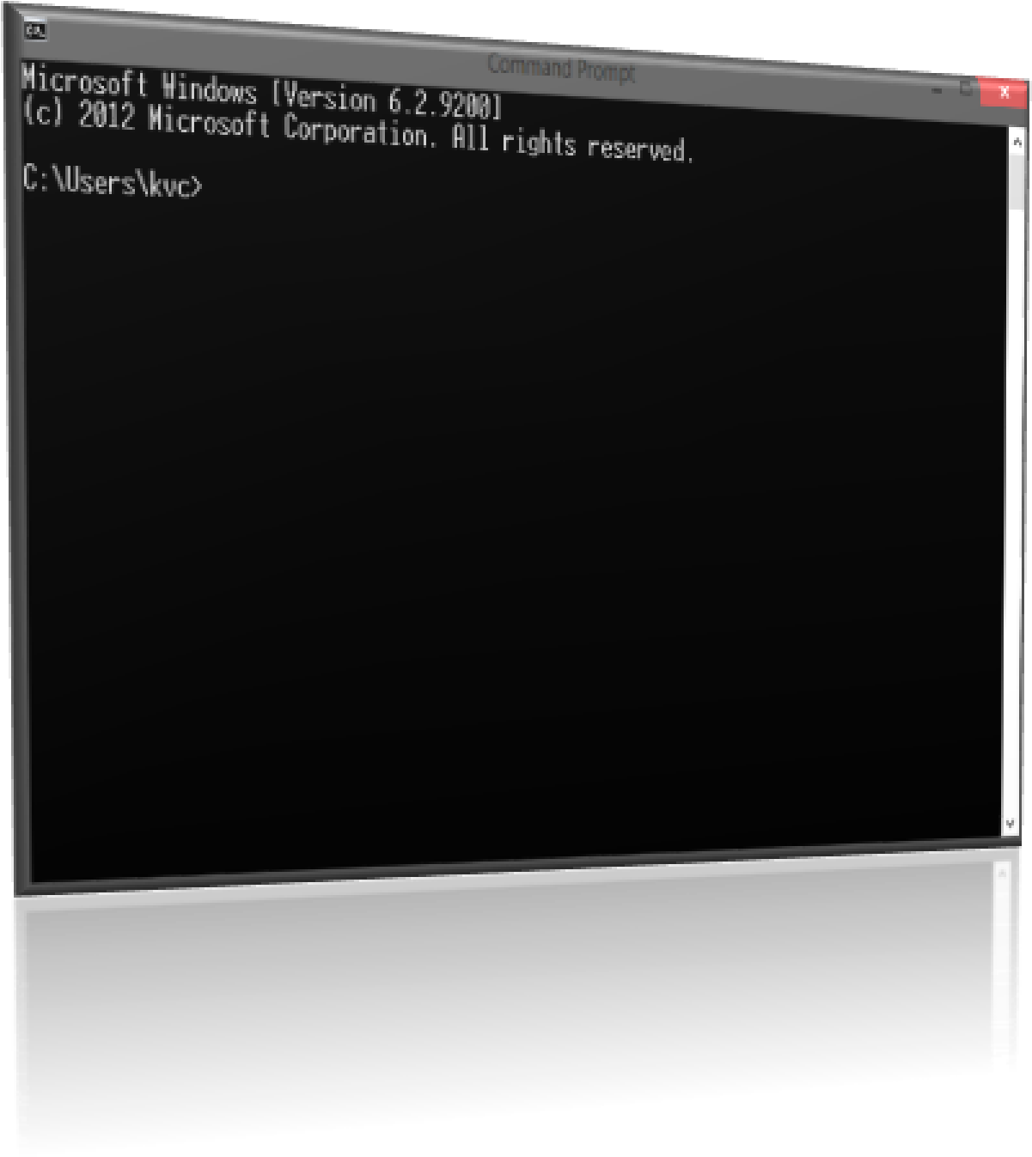

**What this Preview is all about???**

This Preview will help you in understanding…that what I’m trying to do for teaching you batch programming…and it will make you know about What you gonna learn in batch by this book !!

**About The book:**

The Complete Book ‘**Batch Programming Decoded**’ is divided into 5 parts… and each of them will lead you to a step ahead in batch programming…

**Partition info:**

1. **For Newbie**
2. **For beginners**
3. **For Intermediate**
4. **For Programmer**
5. **For advanced programmer**
6. **For ultimate Programmer (**I ‘m not considering this part rights now, as I’m not an ultimate programmer in batch *[as per my ranking]*…so, I have to look in internet only for this particular part…and I’ll start typing this part only on requests…because as you know, internet is a messy sea…and finding useful & original information is like finding needle in hay-stack…**)**

You will see a preview of all topics, you gonna learn in all parts written above, in following pages:

You can also request to my Blog, or E-mail for any special topic in batch. That you think, should be there in this book…

**For Newbie**

1. 10 Lines About this Book
2. Why Batch Files???
3. Basic Requirements for Batch Scripting / Programming …
4. Modes of interaction with System
   1. **Interactive mode**
   2. **Batch Mode (Silent Mode)**
5. Introduction to CMD.exe
6. Introduction to COMMAND.com

**7.** Difference between CMD.exe and Command.com

1. How Cmd Works?
2. What is a Command?
3. Types of Commands :
4. **Internal Commands**
5. **External Commands**
6. How Cmd reacts to Your Commands?
7. Some Basic Commands of Cmd :
   * 1. **Echo**
     2. **Pause**
     3. **Cls**
     4. **Title**
     5. **Dir**
     6. **cd**
     7. **md**
     8. **Goto**

**For Beginners**

1. **10 Lines About this Part**
2. **Some more Commands of cmd**
3. **Prompt**
4. **Attrib**
5. **Call**
6. **Color**
7. **Copy**
8. **Move**
9. **Rem**
10. **Date**
11. **Time**
12. **Del**
13. **Mode**
14. **Ren**
15. **Type**
16. **Important Shortcuts While executing commands in cmd**
17. **What is Batch scripting (or Batch Programming)**
18. **Variable handling in Batch**
19. The ‘*set*’ command…
20. How a variable looks like in batch??
21. Arithmetic Operations on variables…
22. **User interactions with Your Program …*(Getting inputs from user)***
23. **Some Pre-defined variables in batch …*(The environment variables)***
24. **Conditional statement – The If Statement**

**For Intermediate**

1. **10 Lines About this Part**
2. **Loops :**
   * 1. The For loop
     2. Goto command as loop
     3. No while loop in cmd – reason and Creation.
3. **Special operators in batch (>,<,&&,||,&,| etc.)**
4. **Special Parameters in Batch (%0,%1…,%9)**
5. **The Switch Command**
6. **File Handling in batch (**creating, modifying, deleting Files!!**)**
7. **Operators of File-handling (in Details)**
8. ***Functions* in batch…**
9. **String manipulations in Batch…**
10. **Ending + little info about next part**

**For Programmer**

1. **10 Lines About this Part**
2. **Some Advanced Commands of cmd (**network commands**)**
   * 1. **Ping**
     2. **Netstat**
     3. **Net**
     4. **Ftp**
     5. **Pushd (**non-network command**)**
     6. **Popd (**non-network command**)**
3. ***WAP to change your user password …***(net command)
4. **The ‘*path*’ variable & ‘*pathext*’ variable… (Their importance.)**
5. **Compilers for Securing your Source code…(converting to exe)**
6. **Creating your own commands for batch…**
7. **Creating commands from Batch itself!!**
8. **Using other programming languages to make BATCH commands…**
   * 1. **Using VBS for making batch commands**
     2. **Using C or Cpp for making batch commands**
9. **Batch Virus making** (Messing up with commands)
10. **Batch Anti-Virus making** (Partially effective…)

**For Advanced Programmer**

1. **10 Lines About this Part**
2. **Special characters in batch… (Box, Shade box etc…)**
3. **Static GUI programs**
4. **Dynamic GUI programs**
5. **mCmd by kvc** (a Look & how it works)
6. **Error handling in batch…**
7. **Mouse interactions on cmd Console…**
8. **Advanced GUI Programs…**
9. **Ending**

**-------------------------I’m not considering For ultimate user part right now, ------------------**

**-------------------------------------------And you know the reason…-----------------------------------------------**

**#kvc**